Project report for B3:

In this project we use KADAPT to implement Behavior Tree structure:

Our story is call dangerous world:

First:

1. a bad man with red light enters into the scene. He is following a patrol route, when He detect some person looks same as him, he gets mad and run toward them to punch them to death.
2. He killed two people and when the third people detect this bad guy, he wants to escape away from him.
3. The people in the center are just greeting with each other and discuss how dangerous the world is. And then they may wander to some other place.

The behavior tree used in the project are showed below:

For better illustration and convience, I use RainAI diagram to explain:

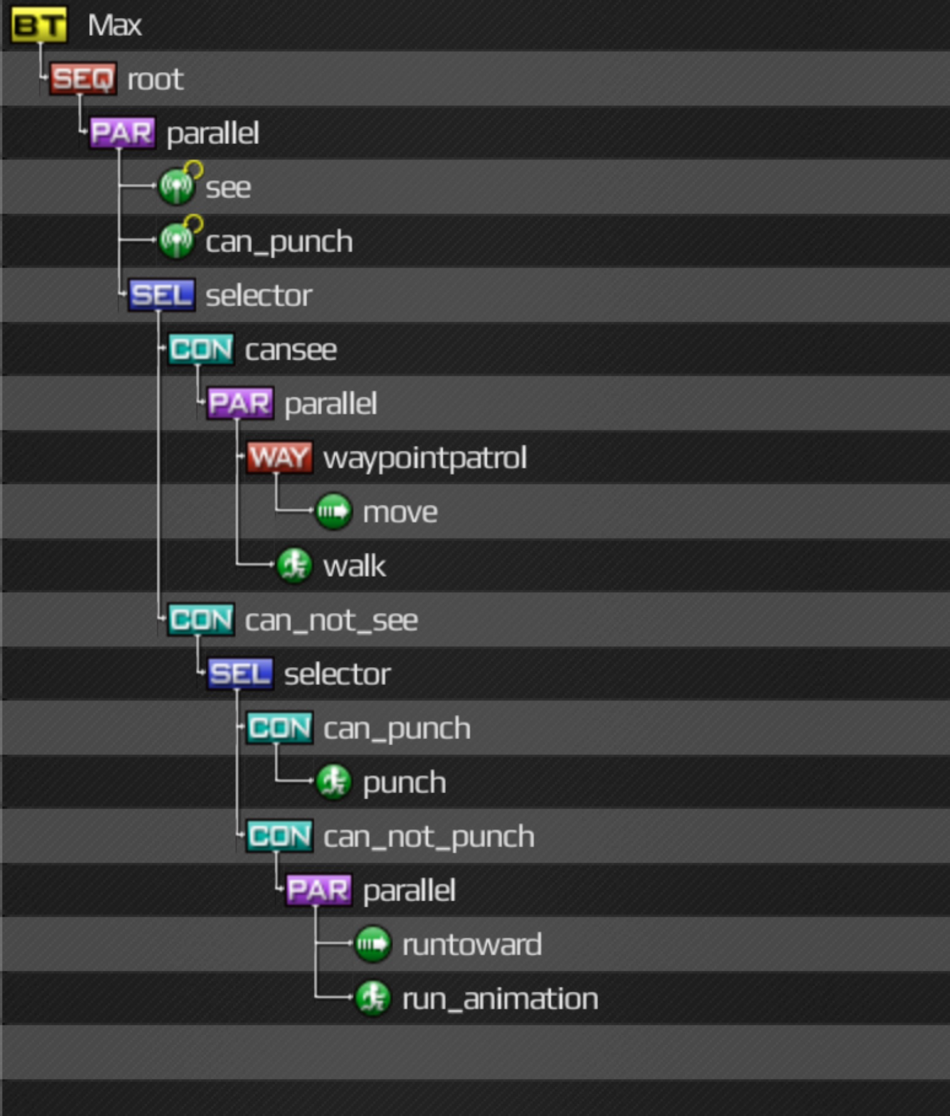

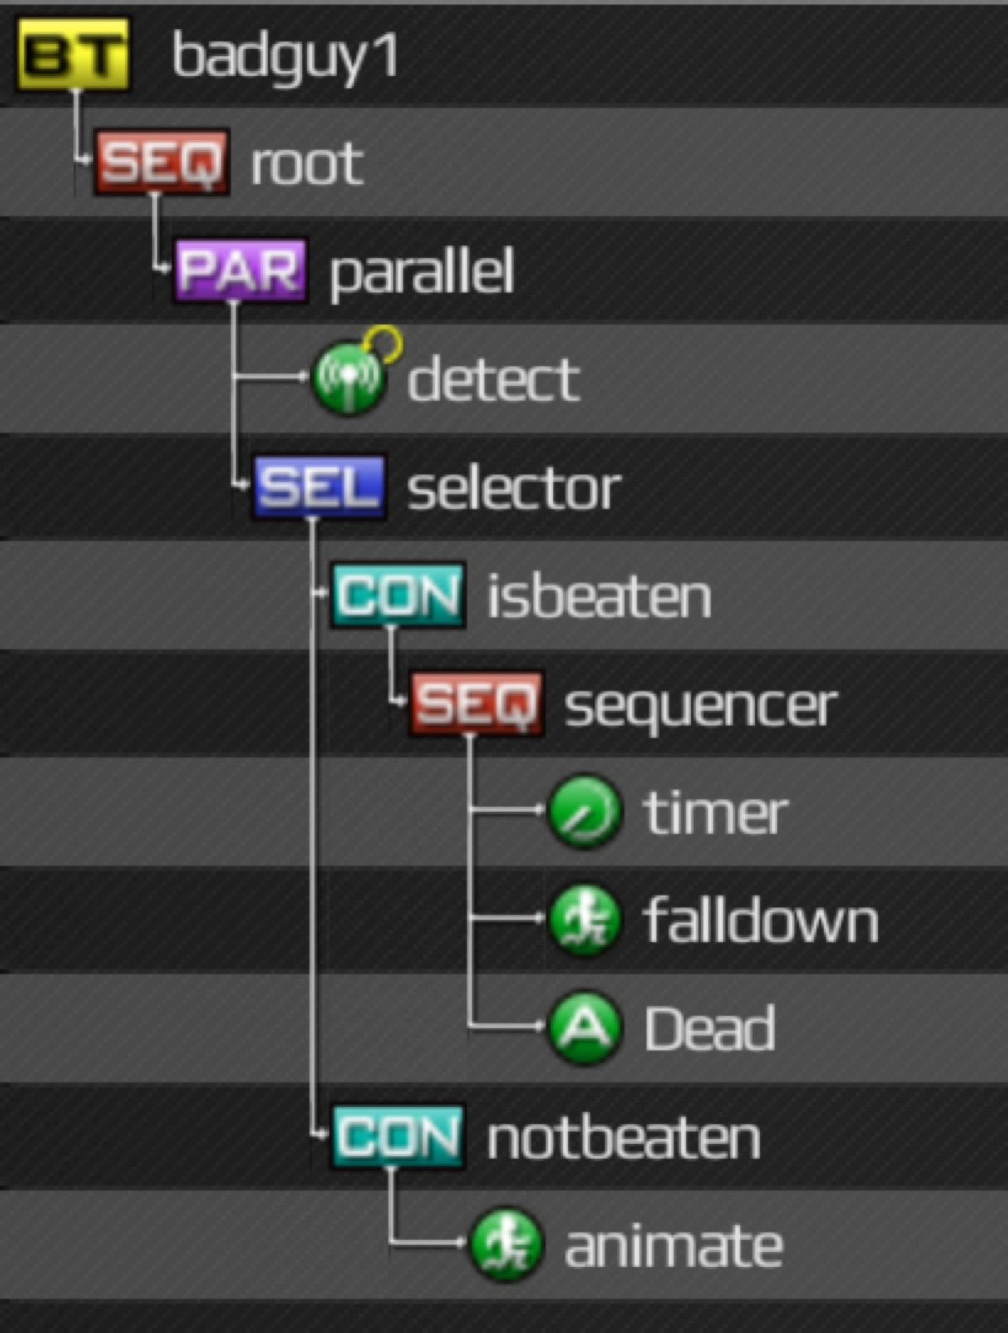

4. We also use KADAPT library to implement a behavior tree. Two men in the room can talk to each other and dialog bubble will show up above their heads while doing some gestures and actions. After that they will keep playing in the room.